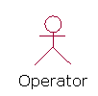

Login

Authentication

Check User

Valid User
Invalid User

Select Option

Add Image
Clip Image
Update Details
Construct Image
Search Process

Enter Details
Open Image& Make Clips
Open Record & Update
Specify Feature
Search Image & Get Details

Add to Database
Add Clips to Database
Add Update Details to database
Send To Search Process
Result

